**REMOTE CONTOL FOR HOME APPLIANCES**

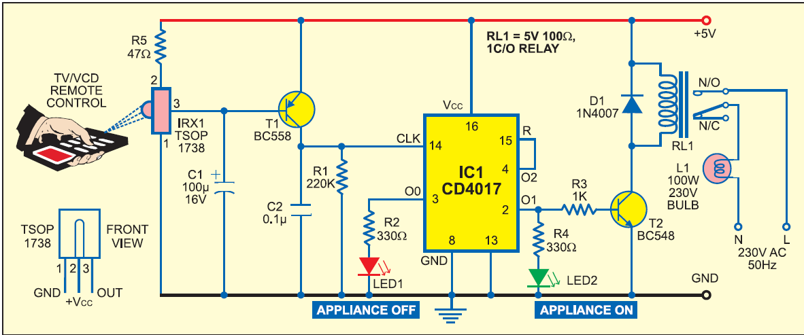

Abstract

We propose to install a system that shall enable an electronic switching device

interfaced with a computer to be controlled remotely using a smart device. A

client running on the user's computer would connect to a central server, over

an Internet connection. The user could then use a HTTP/WAP protocol from

a smart device to connect to the central server, and issue requests to control his

device.

In this report I explain the methodology that this system has adopted to tackle the issue. We also explain

the security considerations that we have focused on while designing the custom client server protocols. In the end, we conclude with possible enhancements in the project that might take us to a whole new world of remotely operated gadgets in every home.

Acknowledgment

***Thank you lord for everything. I never have words to say to you what I wanted to say. But thank you very much.***

***I will not make my parents inferior by giving them thanks. Their dedication, sacrificeness to make me 17 years old. They have provided me all the needs before I beg it. They have also cutteled their expenditure to fulfill my requirements. They have also sacrificed their enjoyment for my study. Moreover they have helped me in all respect to prepare the project a successful one.***

***I am also thankful to my “PHYSICS Teacher”, due to his immense help and inspiration to enable me to represent this project.***

***As the head of the institution my principal is also claimer of thanks due to his creation of suitable environment for our healthy study and proper assistance indirectly by issuing reference PHYSICS books from library and by giving other facility.***

***At the last I would also like to thank my younger brother who also helped me by supplying all the necessary materials to my hand and by not disturbing me while I was doing the project.***

***I hope my project will satisfy in all respect the teacher while she will go through my project.***

*ANIMESH BEHERA*

Contents

Introduction

Computers and the related technologies are becoming more and more ubiquitous.

Various technical arenas in the _eld of Computer Science and Engineering,

or Information Technology have come very near to the common people. The

number of homes with Personal Computers1 is gradually increasing. A day will

come, somewhere in the long future, when PC is referred to in the same class

of \Food, clothing and shelter". Improvements in the Networking technologies

have fostered growth of very dense networks. Land line telephones have been

becoming less and less popular and people now prefer communicating while on

the move. ISPs are now laying down their own networks to provide broadband

Internet access to customers.

When people have a good connectivity at their disposal, with tremendous

power of mobile computing to supplement the same, we can think of \connecting

their home appliances to the mobile phone". With this, people would be able

to turn on and o_, and to some extent, control the appliances at their home

even from a distant place. One of the very basic examples of an utility of this

is { switching on the air conditioner in the room just some time before reaching

home, so that the room is su_ciently cool by then.

About the circuit

**Suitable for operating, Lamps, Fan, Radio etc.., Small n easy unit**  
Here is the circuit diagram of Remote Operated Home Appliances or Remote controlled Home appliances. Connect this circuit to any of your home appliances (lamp, fan, radio, etc) to make the appliance turn on/off from a TV, VCD, VCR, Air Conditioner or DVD remote control. The circuit can be activated from up to 10 meters. It is very easy to build and can be assembled on a veroboard or a general-purpose PCB.

**Parts:**  
R1 = 220K  
R2 = 330R  
R3 = 1K  
R4 = 330R  
R5 = 47R  
C1 = 100uF-16V  
C2 = 100nF-63V  
C3 = 470uF-16V  
D1 = 1N4007  
D2 = Red LED  
D3 = Green LED  
Q1 = BC558  
Q2 = BC548  
IR = TSOP1738  
IC1 = CD4017  
RL1 = Relay 5V DC

**Circuit Operation:**  
The 38kHz infrared rays generated by the remote control are received by IR receiver module TSOP1738 of the circuit. Pin 1 of TSOP1738 is connected to ground, pin 2 is connected to the power supply through R5 and the output is taken from pin 3. The output signal is amplified by Q1. The amplified signal is fed to clock pin 14 of decade counter IC CD4017 (IC1). Pin 8 of IC1 is grounded, pin 16 is connected to vcc and pin 3 is connected to D2 (Red LED), which glows to indicate that the appliance is ‘off.’  
The output of IC1 is taken from its pin 2. D3 connected to pin 2 is used to indicate the ‘on’ state of the appliance. Q2 connected to pin 2 of IC1 drives relay RL1. D1 acts as a freewheeling diode. The appliance to be controlled is connected between the pole of the relay and neutral terminal of mains. It gets connected to live terminal of AC mains via normally opened (N/O) contact when the relay energizes. If you want to operate a DC 12 volt relay then use a regulated DC 12 volt power supply for DC 12 volt Relay and remember that the circuit voltage not be exceeded more than DC 5 volts.

Circuit diagram

[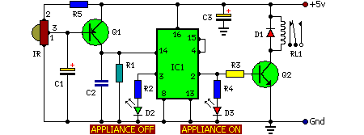](http://lh3.ggpht.com/_FdGFE8NBDgc/SoY-kjgq3VI/AAAAAAAAAko/Y4TlCfCFobo/Remote_Operated_Home_Appliances.GIF)

Working of the circuit

IR remote sensor IC TSOP 1738 is used for recieving the signal. Normally when no signal is falling on IC3 the output of it will be high.This makes Q1 OFF.When a signal of 38 KHz from the TV remote falls on the IC3 its output goes low.This makes Q1 conduct and a negative pulse is obtained at pin 2 of IC 1  NE 555.Due to this IC1 wired as a monostable multivibrator produces a 4 Sec  long high signal at its out put.This high out put is the clock for IC 2 which is wired as a Flipflop and of , its two outputs pin 3 goes low and pin 2 goes high.The high output at pin 2 is amplified to drive the relay .For the next signal  the outputs of IC2 toggles state. Result, we get a relay toggling on each press on the remote.Any appliance connected to this circuit can be switched ON or OFF.

Circuit in detail

**C**onnect this circuit to any of your home appliances (lamp, fan, radio, etc) to make the appliance turn on/off from a TV, VCD or DVD remote control. The circuit can be activated from up to 10 metres. The 38kHz infrared (IR) rays generated by the remote control are received by IR receiver module TSOP1738 of the circuit. Pin 1 of TSOP1738 is connected to ground, pin 2 is connected to the power supply through resistor R5 and the output is taken from pin 3. The output signal is amplified by transistor T1 (BC558). The amplified signal is fed to clock pin 14 of decade counter IC CD4017 (IC1). Pin 8 of IC1 is grounded, pin 16 is connected to Vcc and pin 3 is connected to LED1 (red), which glows to indicate that the appliance is ‘off.’ The output of IC1 is taken from its pin 2. LED2 (green) connected to pin 2 is used to indicate the ‘on’ state of the appliance. Transistor T2 (BC548) connected to pin 2 of IC1 drives relay RL1. Diode 1N4007 (D1) acts as a freewheeling diode. The appliance to be controlled

is connected between the pole of the relay and neutral terminal of mains. It gets connected to live terminal of AC mains via normally opened (N/O) contact when the relay energises.

Notes on the circuit

* Before wiring the circuit make sure that the carrier frequency  of the TV remote you have is 38 KHz.For that wire the sensor part only ,point your remote to the TSOP1738 and press any switch.If  out put of TSOP1738  goes  low them ok, your remote is of 38Khz type.Nothing to worry almost all TV remote are of this type.
* You can use any switch because for any switch the code only changes,the carrier frequency remains same.We need this carrier frequency only.
* Assemble the circuit on a good quality PCB or common board.
* The appliance can be connected through NO or NC  and contacts of the relay .

Conclusion

The circuit consists of very less components and simple in design.

Connect this circuit to any of your home appliances (lamp, fan, radio, etc) to make the appliance turn on/off from a TV, VCD or DVD remote control. The circuit cane activated from up to 10 metres. The 38kHz infrared (IR) rays generated by the remote control are received by IR receiver module TSOP1738 of the circuit. Pin 1 of TSOP1738 is connected to ground, pin 2 is connected to the power supply through resistor R5 and the output is taken from pin 3. The output signal is amplified by transistor T1 (BC558).  
The amplified signal is fed to clock pin 14 of decade counter IC CD4017 (IC1). Pin 8 of IC1 is grounded, pin 16 is connected to Vcc and pin 3 is connected to LED1 (red), which glows to indicate that the appliance is ‘off.’ The output of IC1 is taken from its pin 2. LED2 (green) connected to pin 2 is used to indicate the ‘on’ state of the appliance. Transistor T2 (BC548) connected to pin 2 of IC1 drives relay RL1. Diode 1N4007 (D1) acts as a freewheeling diode. The appliance to be controlled is connected between the pole of the relay and neutral terminal of mains. It gets connected to live terminal of AC mains via normally opened (N/O) contact when the relay energises. you can use any NPN transistor inplace of BC548. You can also use SL100 or any NPN transistor lying around you.

The delay depends on the C1 capacitor. Using higher value capacitor will create more delay and using less value capacitor will switch the circuit more than 2 times when you press a remote. Analyse the circuit by placing the 10uf capacitor in place of C1 (100uf).